Experiment 9
Name: Maithili Sawant
Roll No: 33
Class: SE3

Aim: Implement a search functionality to filter API results dynamically.
Code:
INDEX.JS
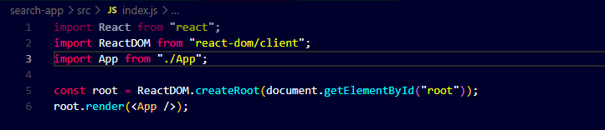

APP.JS
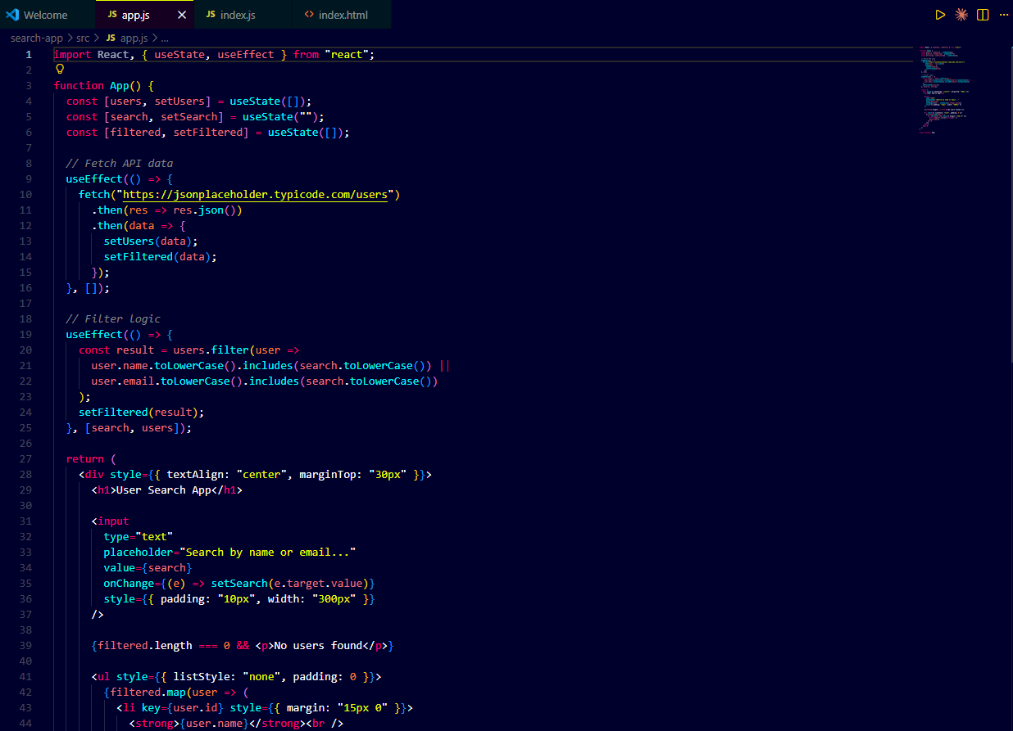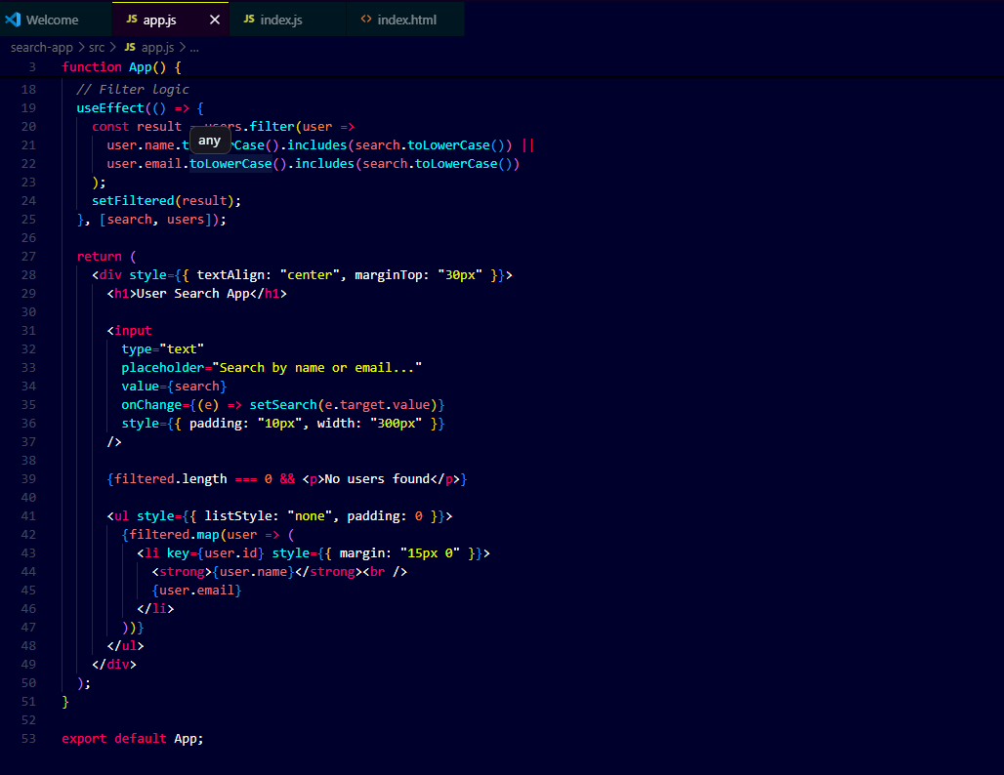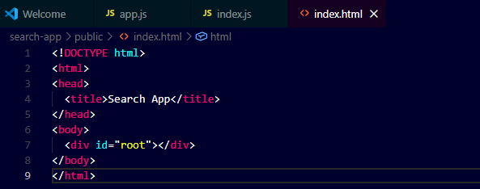

OUTPUT:
